**Annex 1   
Nominal Entry**

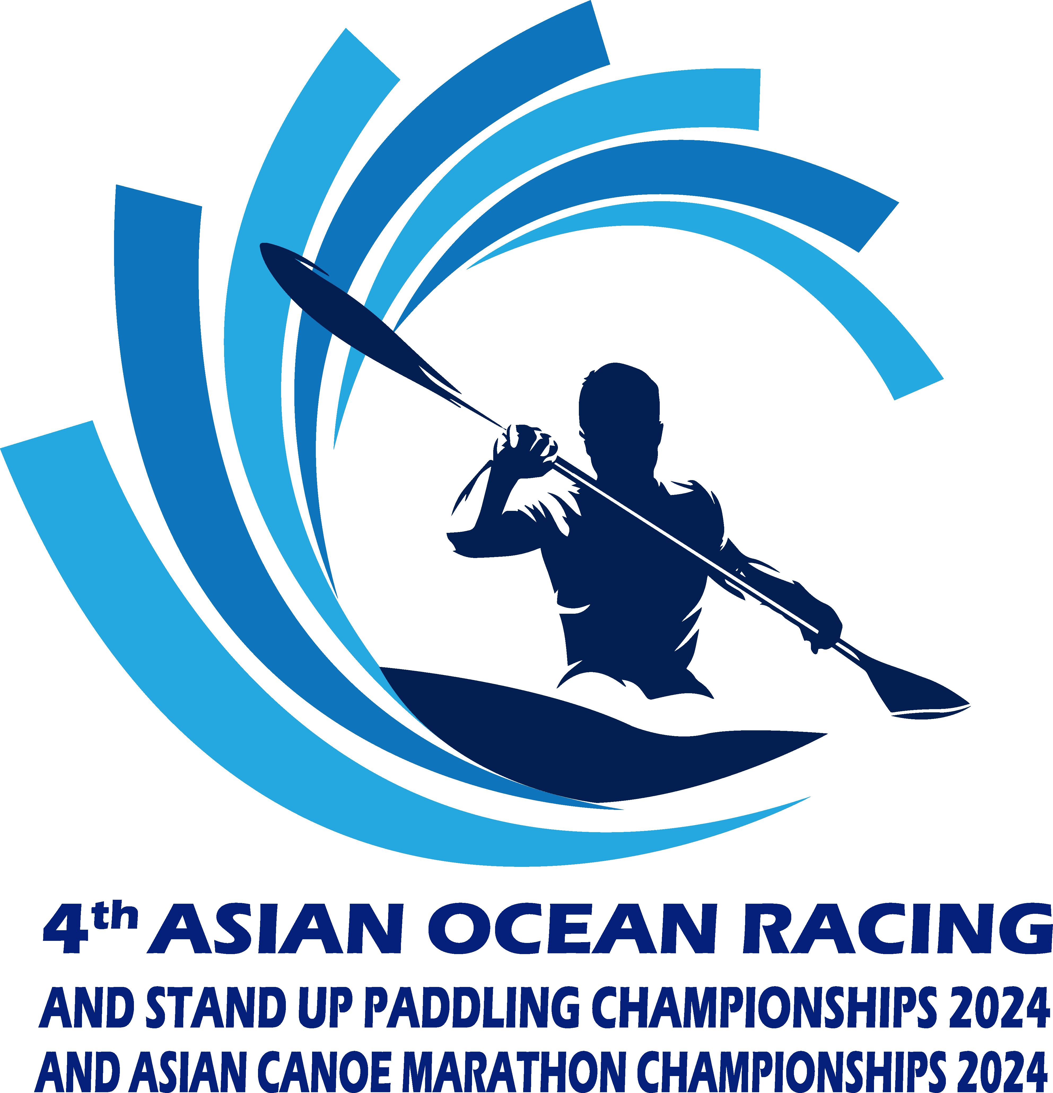

**National Federation:**

|  |  |  |  |  |  |  |
| --- | --- | --- | --- | --- | --- | --- |
| **No.** | **Name** | | **Date of Birth (dd/mm/yyyy)** | **Event**  **(COR, CAM SUP)** | **Type**  **(OC-1, SS, C1, K1, SUP)** | **Class** |
|  |  | |  |  |  |  |
|  |  | |  |  |  |  |
|  |  | |  |  |  |  |
|  |  | |  |  |  |  |
|  |  | |  |  |  |  |
|  |  | |  |  |  |  |
|  |  | |  |  |  |  |
|  |  | |  |  |  |  |
|  |  | |  |  |  |  |
|  |  | |  |  |  |  |
|  |  | |  |  |  |  |
|  |  | |  |  |  |  |
| Total number of athletes:   * Male: * Female: | | | | | | |
|  | | Name of contact person(s) who can be contacted while in Thailand: | | | | |
|  | | Email: | | | | |
|  | | Phone Number /WhatsApp: | | | | |
|  | | Authorized signature and Federation stamp:  Name and Position: Date (dd/mm/yyyy): | | | | |

Please email to [***cam.cor.rcat@gmail.com***](mailto:rcat.cspevents@gmail.com) ***by 30 September 2024***